

**LG AF-Q236GMC0**

**Rs. 298,200/-**

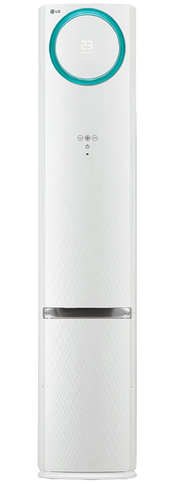

**Product Features**

* Econo Cool
* New LEV Control
* Electronic Metal Housing Box
* Self-diagnostic Function
* 15M Long Distance Airflow

**Specification**

**Type** Wall Mounted Split AC

**Cooling (Btu/h)** 57000

**Voltage (V)** 220-240

**Power Input (W)** 4800

**EER (Btu/W-h-W/W)** 7.3-4.5